Lab Exercise : 4
1. Use CSS animation properties to animate cycle and move from left to right.
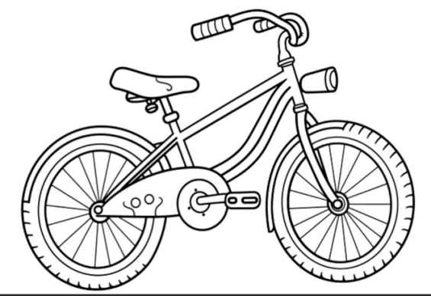

- Use CSS animation properties to animate square and change the color of that shape.
- Write a HTML Code to perform Tooltip in CSS.
(eg: User Hover mouse on Subject then Subject List will display.)

